Query Results
1.Verify Data
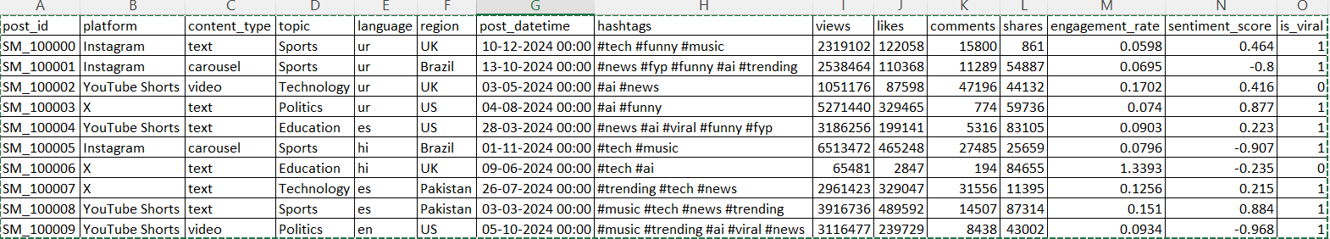

2. Basic Data Understanding
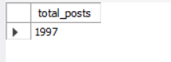

3. Platforms Available.
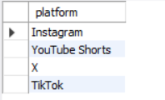
4. Viral vs Non-Viral Analysis.
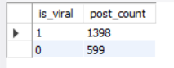
5.Platform Performance.
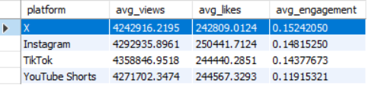
6. Content Type Analysis.
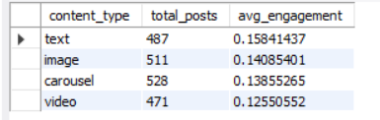
7. Topic-wise Viral Content.
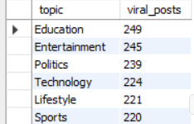
8. Region Performance.
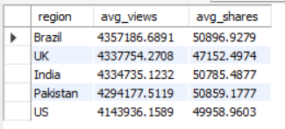
9. Sentiment vs Virality.
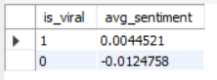
10. Time-Based Analysis.
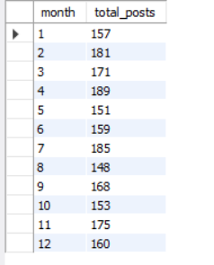
11. Top 10 Most Engaging Posts.

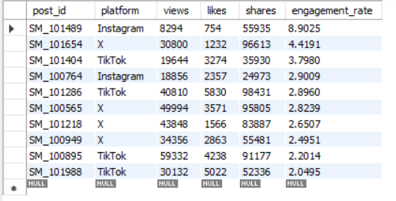
12. Business Insights.
